IAN BROUGHTON TOURNAMENT
On Sunday 30th June the 3rd annual Ian Broughton Tournament was held, with 20 players taking part, all of whom enjoyed a day of competitive and friendly tennis.
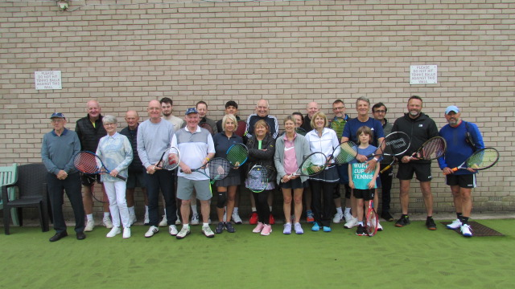
Many thanks to Arthur for his superb organising of the days events which went on without a hitch despite the weather.
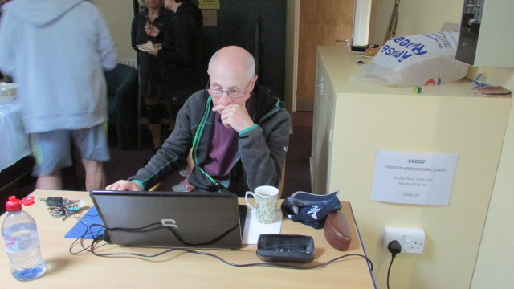
Also, thanks to the kitchen and bar staff for their hard work on the day ensuring that all were well fed and watered.
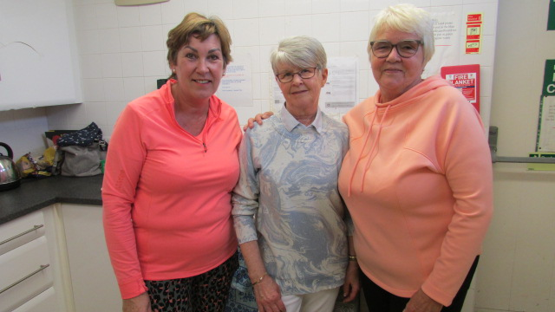
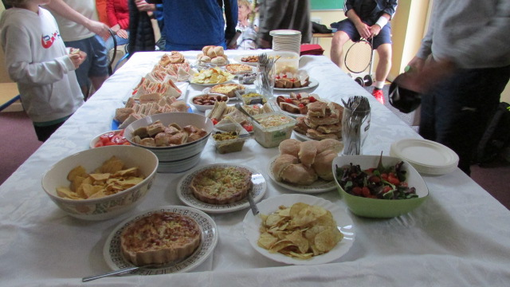
Special thanks to Gordon and Ann (current President, and wife) for their support and to Gill Broughton for supporting and presenting the trophies.
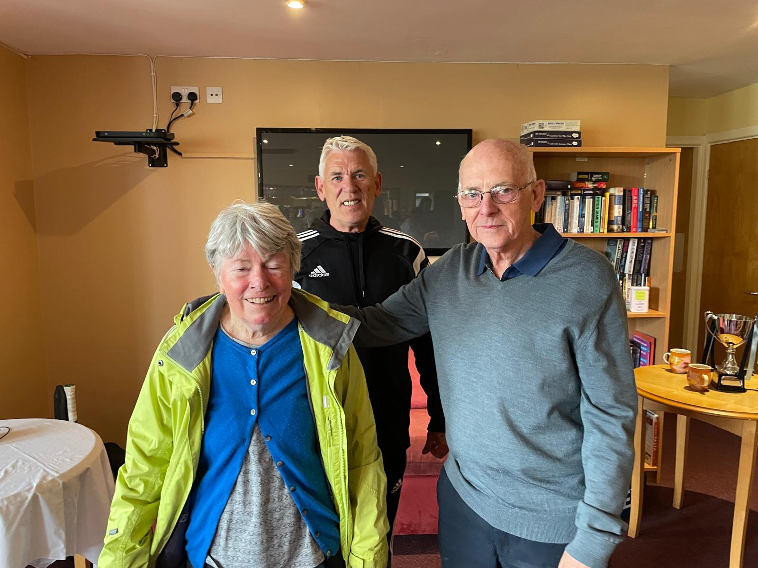
Our youngest entrant was Gus Seed who played well with all his partners. His budding skills on court did not quite match his dad Adam who again finished as runner up. This was a small example of the basis of the tournament, taking part.
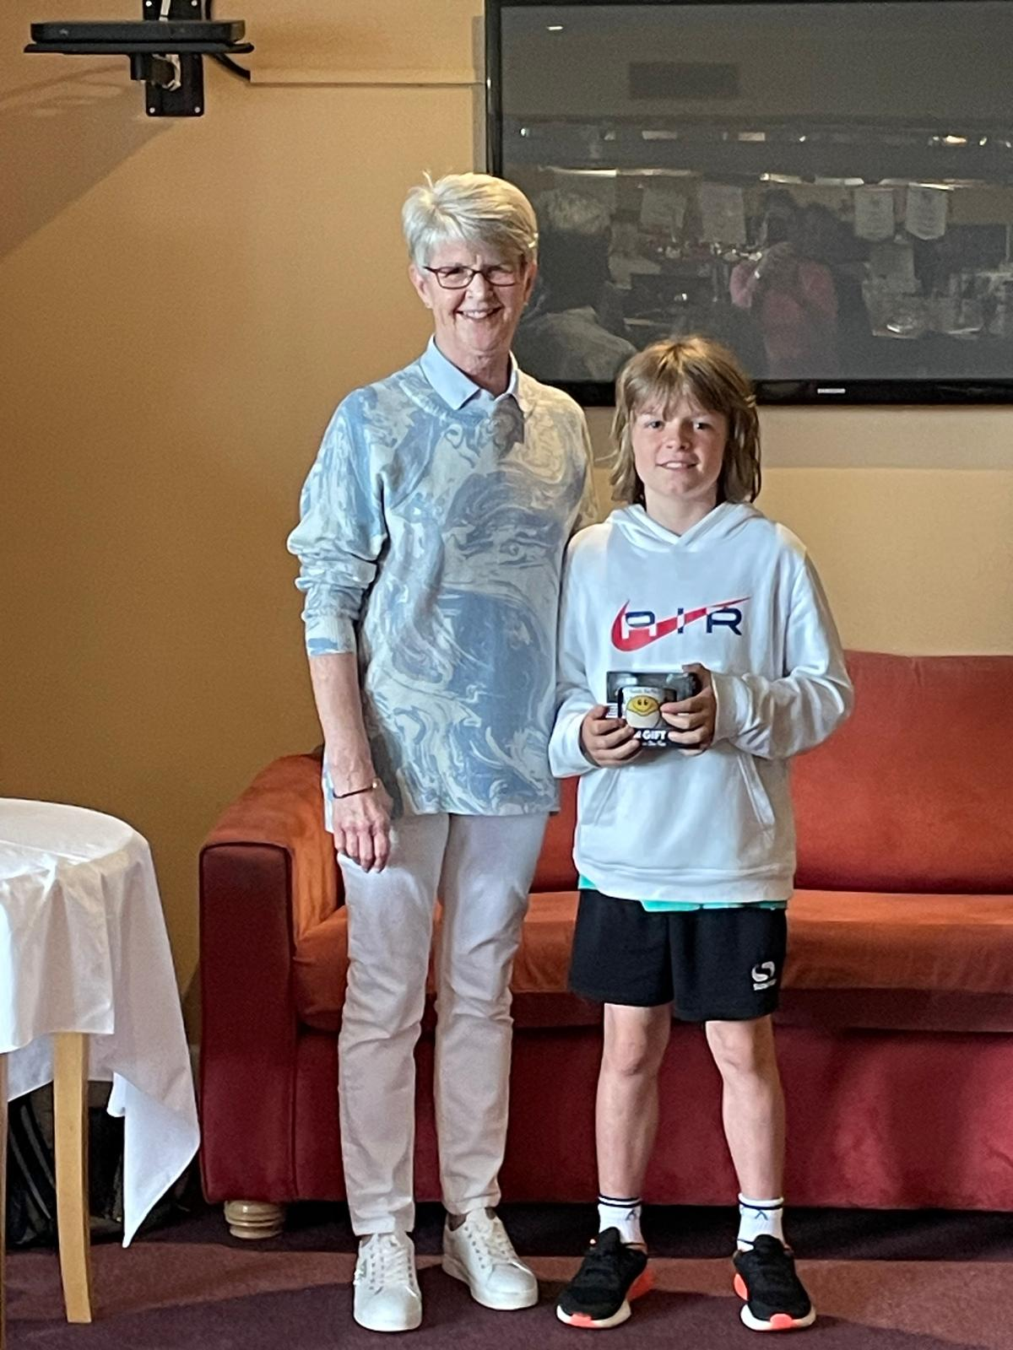The competition was very close until the end when our eventual winner was crowned, congratulations to Andy White. 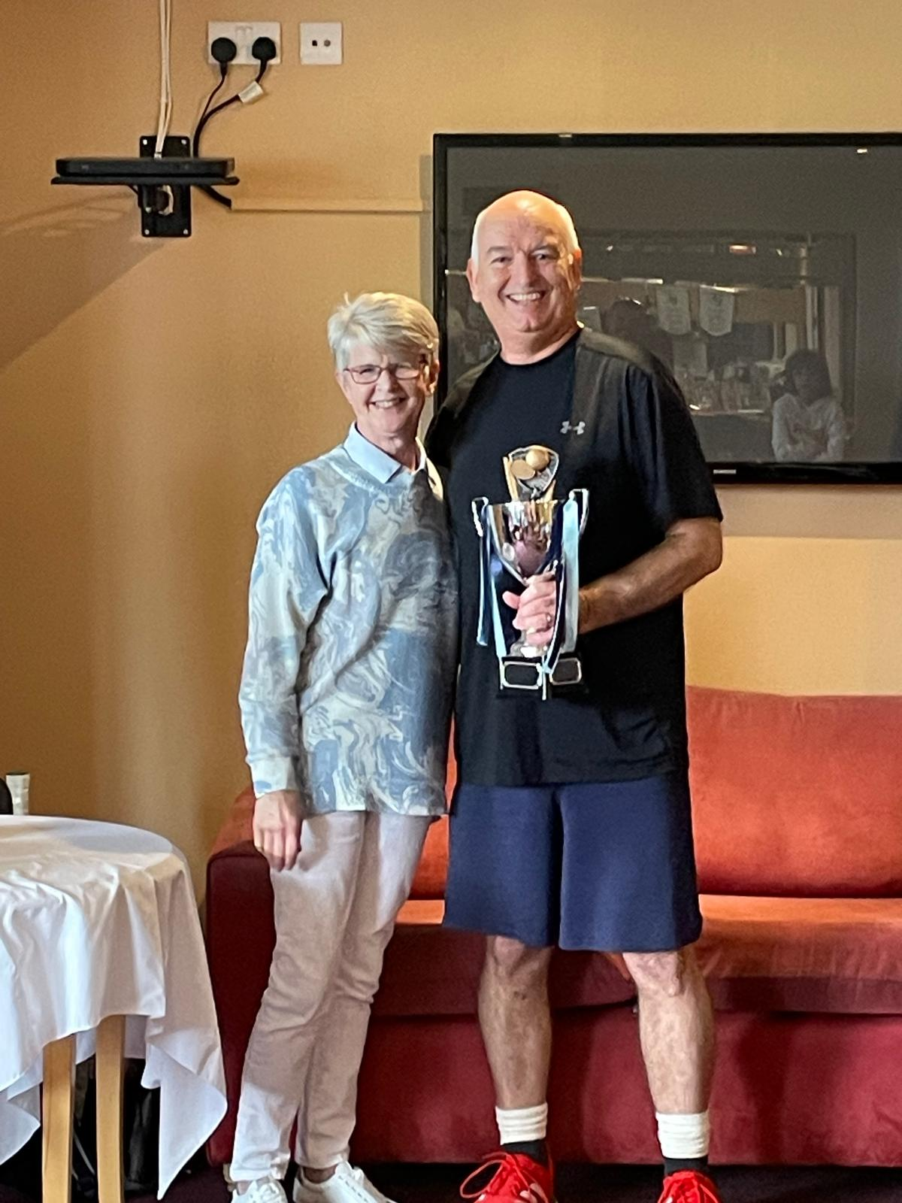

Thanks to all those who turned up to support the event and we will look forward to a repeat next year.
